

Dynamic Planet C
Cornell Invitational 2022
Time limit: 50 minutes

Directions
- ***Do NOT open the packet until directed to do so by the tournament proctor(s).
- Please write final answers in the answer packet. Work written on this packet will NOT be graded.
- Allowed materials: Each team may bring one three-ring binder and two stand-alone calculators of any type.
- Multiple choice, 1 pt each: Please write the letter of the answer to each multiple choice question IN CAPITAL LETTERS. No credit will be given for illegible or unclear answers.
- True/false: Please make it clear what your answer is, whether you write the letters “T” or “F” or write out the entire word “true” or “false.” If it’s unclear, no credit will be given.
- Short answer questions: Partial credit may be earned on short answer questions. Generally, please keep written answers short and concise.
- Tiebreakers are marked in the test and answer packet in the order they will be broken (e.g., “TB1” is the first tiebreaker, “TB2” the second, etc.). In order, by (section.number) format:
  - 6.3 / 1.21 / 7.3 / 1.12 / 3.5 / 1.22 / 5.9 / 1.16

Section 1: Multiple Choice [25 pts]
- An artificial channel with original flow velocity v is redesigned such that the width is increased by 20%. Assuming that discharge is constant, what is most nearly the new flow velocity?
  - 1.20v
  - 1.13v
  - v
  - 0.83v
  - 0.80v

- As a stream slows down, what is the first and second type of load to be deposited, in order?
X. Suspended load
Y. Dissolved load
Z. Bed load

  - X then Y
  - X then Z
  - Y then X
  - Y then Z
  - Z then X
  - Z then Y

- At a certain point in a stream, the Strahler stream order is 2. How many tributaries upstream have fed into this point?
  - Exactly 2
  - At least 2
  - At most 2
  - At least 3
  - At most 3
  - Not enough information

- A narrow stream with fast moving waters likely has
  - high capacity and competence
  - low capacity and competence
  - high capacity but low competence
  - high competence but low capacity

- Given that C is Chezy’s coefficient and n is Manning’s roughness coefficient, C is proportional to
  - n
  - n²
  - $\sqrt{n}$
  - –n
  - $\frac{1}{n}$

- In which of these environments would you be most likely to find smooth, rounded pebbles?
  - Near the headwaters of a stream
  - In the middle of a large, calm lake
  - At the riverbank of a stream near the sea
  - Both (a) and (b)
  - Both (a) and (c)
  - Both (b) and (c)

- Fog forming over a warm lake on a cold day is due to
  - Evaporation
  - Condensation
  - Precipitation
  - Sublimation
  - Deposition
- A scientist is modeling the flow of a slow-moving straight stream, assuming the flow is laminar throughout. Where, if any, does this assumption more accurately model real-world conditions?
  - Near the center of the stream
  - Near the bottom and sides of the stream
  - Both (a) and (b) (assumption is equally valid)
  - Neither; slow-moving streams usually have turbulent flow throughout

- Considering the global water budget, if P is precipitation, E is evapotranspiration, and R is runoff, which of these is true for land regions overall?
  - P > E > R
  - P > R > E
  - E > P > R
  - E > R > P
  - R > E > P
  - R > P > E

Consider the following table for questions 10 and 11.
Sample | Porosity | Permeability (cm²)
A | 0.05 | 10⁻¹¹
B | 0.25 | 10⁻¹¹
C | 0.05 | 10⁻⁶
D | 0.25 | 10⁻⁶

- Which sample was most likely collected from a karstic region?
  - A
  - B
  - C
  - D

- An aquifer that has the same composition as which of the above samples would be the most productive?
  - A
  - B
  - C
  - D

- [TB4] Suppose you see the following symbol on a USGS topographic map exactly as shown (assume top of the map is north).

Which of these can be reasonably inferred from the above?
- This stream flows from west to east
- At the eastern end of the symbol, the water table is more steeply sloped than the land surface
- This stream flows intermittently

- I, only
- III, only
- I and II, only
- I and III, only
- II and III, only
- I, II, and III

- A sample of sediment transported over a long distance has a nearly uniform grain size. Which of these best describes the sediment?
  - Angular and well sorted
  - Angular and poorly sorted
  - Rounded and well sorted
  - Rounded and poorly sorted

- Which of these is/are true about acid mine drainage (AMD)?
- AMD often decreases the pH of the waters it contaminates
- AMD contains heavy metals
- AMD contains organic pollutants and phosphates

  - I, only
  - II, only
  - III, only
  - I and II, only
  - I and III, only
  - II and III, only

- Which of these, if any, is/are favorable to delta growth?
  - Construction of a flood-control dam upstream
  - A shift from a tide-dominated to river-dominated environment
  - Both (a) and (b)
  - None of the above

- [TB8] Which of these, if any, is/are true about pingos?
  - A warming Arctic would favor more hydraulic pingos than hydrostatic pingos
  - Lakes can form as a result of pingo rupture
  - Both (a) and (b)
  - None of the above

- Which of these most accurately describes braided stream channels?
  - They have low turbidity and deposit fine sediments
  - They have low turbidity and deposit coarse sediments
  - They have high turbidity and deposit fine sediments
  - They have high turbidity and deposit coarse sediments

- Lake Baikal, the Dead Sea, and Lake Vostok are all
  - saltwater lakes
  - endorheic basins
  - lakes formed by glaciation
  - lakes formed by rifting
  - lakes formed inside volcanic cones

- Caldera lakes are most likely associated with which of these drainage patterns?
  - Rectangular
  - Dendritic
  - Trellis
  - Radial

- Which of these methods would give the most accurate way to determine the thickness of the zone of aeration at your location? Assume uniform bedrock.
  - Use a map to determine the elevation difference between your location and the nearest stream
  - Use a soil moisture sensor to determine the depth at which soil moisture is first detectable
  - Use a tape measure that extends into a well until it makes contact with the water table
  - Either (a) or (c) should give the same approximate result
  - Either (b) or (c) should give the same approximate result

- [TB2] A 100-year flood occurred in a town in 2015. Which of these, if any, can be reasonably inferred?
- More likely than not, the next 100-year flood will occur during the year 2115
- More likely than not, a 10-year flood occurred or will occur in the 2015-2025 period

  - I, only
  - II, only
  - I and II
  - None of the above

- [TB6] Refer to Image A, showing four numbered streams emptying into a sea. Assume discharge in streams 1, 2, and 3 are equal. Eventually, what is most likely to happen?
  - Stream 1 captures stream 2, and stream 4 is fed only by stream 3
  - Stream 2 captures stream 1, and total discharge in stream 4 increases
  - Stream 2 drains into both stream 1 and stream 4, and total discharge of stream 1 and stream 4 increases
  - Stream 1 captures stream 2, and stream 3 flows into stream 1
  - All the streams merge into one stream

- Assuming a typical dimictic lake, during which season(s) is the epilimnion temperature most likely equal to the hypolimnion temperature?
  - Spring only
  - Summer only
  - Autumn only
  - Winter only
  - Spring and autumn
  - Summer and winter

- Which of these shows a possible progression of karst features with time?
  - Sinkhole → solution valley → cave
  - Sinkhole → cave → solution valley
  - Cave → sinkhole → solution valley
  - Cave → solution valley → sinkhole
- You find that the water level in a well is different from the water table. This is likely due to the water level being ___ than the water table due to a ___-grained confining unit.
  - shallower; fine
  - shallower; coarse
  - deeper; fine
  - deeper; coarse

Section 2: Ithaca is Gorges [15 pts]
For questions 1-3, refer to Image B, a photo of Salmon Creek Falls in Ithaca, NY (taken by the author of this event).

- (0.5 pt) Do graded or ungraded streams typically have several waterfalls along the stream?

- (0.5 pt) True or false: The waterfall shown in the image empties into a plunge pool, whose surface is below the local base level.

- (2 pts) There are two rock units evident in the image. Briefly describe (in 1-2 sentences) how the top unit is physically different from the bottom unit. Will the waterfall advance or retreat over time, and how does this change occur?

- (2 pts) On average, during which season would the streamflow on Salmon Creek be the highest? What is the main cause of high streamflow during this season?

- (1 pt) Salmon Creek drains into Cayuga Lake. If the lake level of Cayuga Lake were to lower, indicate if the following would increase, decrease, or remain constant:
  - Ultimate base level
  - Rate of stream downcutting

For questions 6-8, refer to Image C, a zoomed-in image with a part of Salmon Creek.
- (0.5 pt) Is the stream velocity higher near point 1 or near point 2?

- (0.5 pt) Which of these factors can be used to justify your answer to question 6?
  - The difference in gradient on the two sides of the stream
  - The shape of the stream
  - Both (a) and (b)
- (2 pts) Fill in the blanks on your answer sheet: Point 1 is a(n) (erosional / depositional) feature called a(n) ___, whereas Point 2 is a(n) (erosional / depositional) feature called a(n) ___.

For questions 9-13, refer to Image D. The top of the map is north. Salmon Creek is the main channel located on the east side of the map.
- (0.5 pt) True or false: Water from wetland A enters directly into the Salmon Creek watershed.

- (2 pts) Classify each wetland (A and B) as either a bog or a marsh. Which wetland, if any, has a larger proportion of its water coming directly from precipitation?

- (2 pts) Assuming water table contours are approximately parallel to the contour lines, is the tributary marked by “1” a gaining or losing stream? Justify your answer by describing groundwater flow direction.

- (0.5 pts) If a map of groundwater flow velocities were available, in which wetland would you expect to see slower groundwater flow?

- (1 pt) Suppose a localized shower occurred north of the region on the map, bringing rain to upstream areas of Salmon Creek and its tributaries. Suppose hydrographs were drawn for points 1 and 2. Which point would have a hydrograph
  - with a later peak?
  - with a taller peak?

Section 3: Flood! [13 pts]
On January 18, 1996 and several days after, widespread severe flooding occurred in the Northeastern US. Unusually warm air and widespread rainfall contributed to the flooding. Before the flooding, many areas had snow depths over 2 feet.

- (1 pt) All else equal, if temperatures were warmer and there were no snow on the ground, indicate if each of the following would increase, decrease, or remain the same:
  - Ground permeability
  - Rate of runoff

- (1 pt) Rain fell over a 6 to 12 hour period in many locations. If the same amount of rain were to fall over a 24-hour period, all else equal, the flooding would be:
  - more severe
  - less severe
  - about the same severity

- (2 pts) The relative humidity (the extent to which the air was saturated with water vapor) was quite high across the Northeast. Explain how high relative humidity contributes to faster snow melt. (Hint: there is another phase change involved besides melting.)

Refer to the following hydrograph for questions 4-6 (source: USGS).
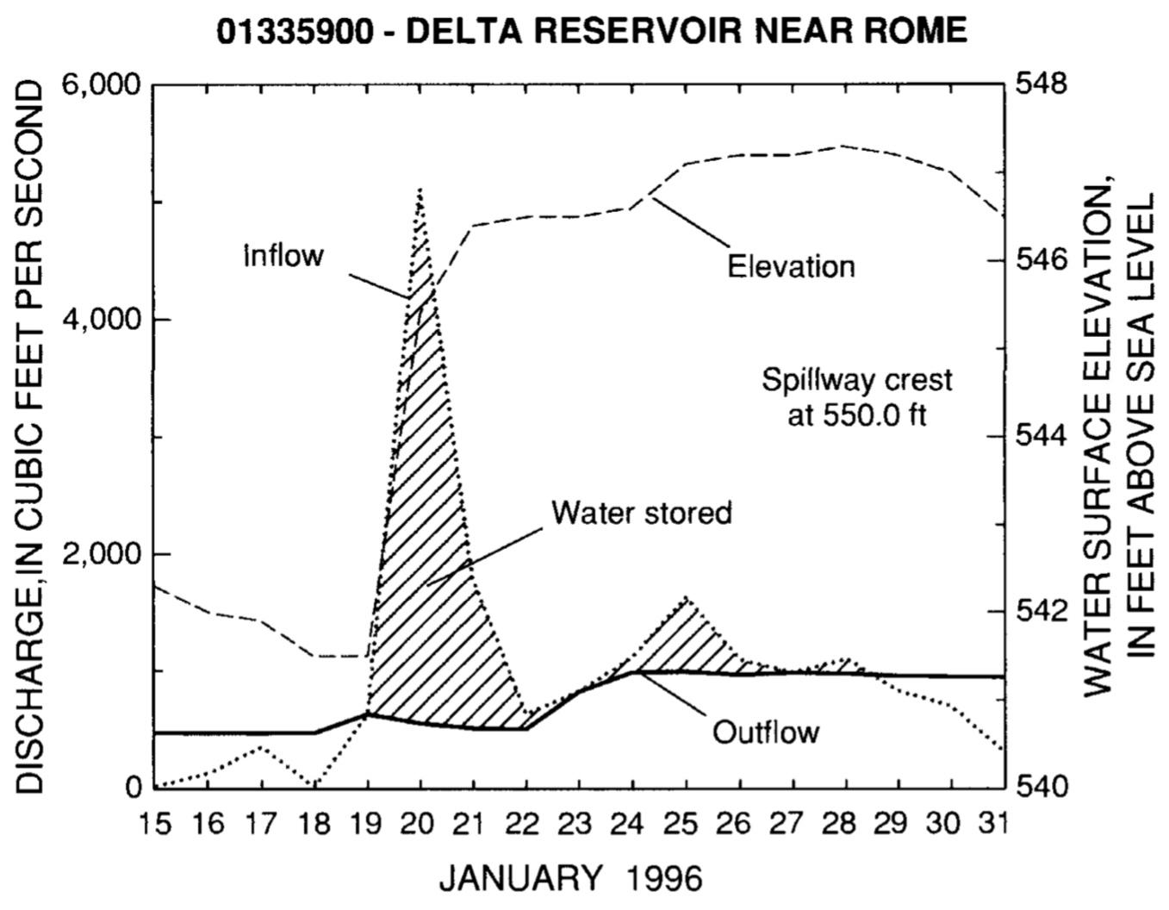

- (1 pt) Estimate the average rate of increase of discharge from January 19 to January 20. Include the proper units in your answer.

- [TB5] (1 pt) The water elevation continued to increase after the flood, even as inflow sharply decreased. In a sentence, briefly explain why this was the case.

- (2 pts) If the trees around Delta Reservoir were cleared, predict what would happen to:
  - the turbidity of the lake. Briefly explain.
  - average dissolved oxygen (DO) levels in the lake
  - the peak discharge of the flood

For questions 7-9, consider the following data table of discharge (in thousands of cubic feet per second) and a rating curve, both for the Susquehanna River at Marietta, PA.

January 20, 1996 |  |  |  | January 21, 1996
1am | 7am | 1pm | 7pm | 1am | 7am | 1pm | 7pm
146 | 392 | 464 | 565 | 587 | 586 | 562 | 523

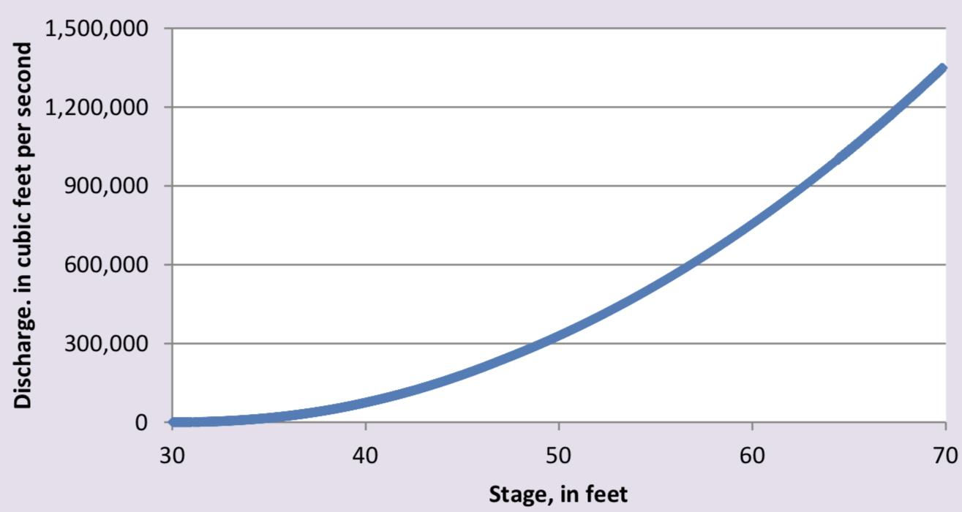
Credit: Maryland Dept. of Natural Resources

- (1 pt) During which six-hour time interval on which day did the river surpass a stage of 50 feet? Also estimate the maximum flood stage (in feet) during the two-day period.

- (1 pt) Widening the Susquehanna River would result in a curve that has
  - a steeper curve than the one shown
  - a flatter curve than the one shown
  - about the same curve as the one shown

- (1 pt) At the Harrisburg, PA stream gauge (upstream of Marietta, PA), the 100-year flood stage is only 29 feet. Assuming the river stage is measured relative to the bottom of the channel bed, and that river velocity and discharge are constant:
  - the river width is constant, so the river is probably deeper in Harrisburg
  - the river width is constant, so the river is probably deeper in Marietta
  - the cross-sectional area is constant, so the river is probably wider in Harrisburg
  - the cross-sectional area is constant, so the river is probably wider in Marietta

- (1 pt) Ice jams were also a hazard in the January 1996 floods. Typically, when an ice jam occurs, are areas upstream or downstream more likely to be flooded first? Do ice jams more easily occur in straight or meandering streams?

- (1 pt) On a flood frequency curve, the annual maximum ___ is plotted against ___.

Section 4: Lake water budgets and residence times [7 pts]
- (2 pts) Lake Superior, a large freshwater lake, has a volume of 12,100 km³. Earth’s freshwater lakes hold an estimated volume of 91,000 km³. Assuming that the average residence time for water in Lake Superior is 190 years, calculate an estimate for the average freshwater flux into Lake Superior in m³/yr. Show your calculations.

Refer to the following for questions 2-3. A student writes down six formulas for residence time where V = lake volume, E = evaporation rate, and = outflow rate.

Equation 1 | 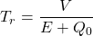 | Equation 2 | 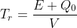
Equation 3 | 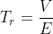 | Equation 4 | 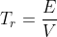
Equation 5 | 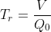 | Equation 6 | 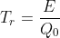

- (2 pts) Out of these formulas, which one is the most accurate to calculate the residence time for water? For sodium ions?

- (0.5 pt) Generally, which residence time is longer: water residence time or sodium ion residence time?

- (0.5 pt) If two nearby lakes have equal outflow rates and equal initial pollutant concentrations, but have unequal sizes, will the smaller lake or the larger lake be less polluted after a certain time?

- (2 pts) During a certain month, precipitation is 2.8 in, evapotranspiration is 1.5 in, net groundwater inflow is 0.5 in, and runoff is 0.8 in for a lake. Calculate the equivalent change in storage (in inches) for the lake. Show your calculations. Include either a positive or negative sign of the change, if applicable.

Section 5: Lake hydrology more because it’s awesome [16 pts]
For questions 1-3, refer to the following hypsographic curves. The first shows a plot of depth (y-axis) vs. cross-sectional area (x-axis), and the second shows a plot of depth vs. percent area. The solid line (—) corresponds to the curve for Lawrence Lake, which is oligotrophic, and the dashed line (––) corresponds to the curve for Wintergreen Lake, which is eutrophic.
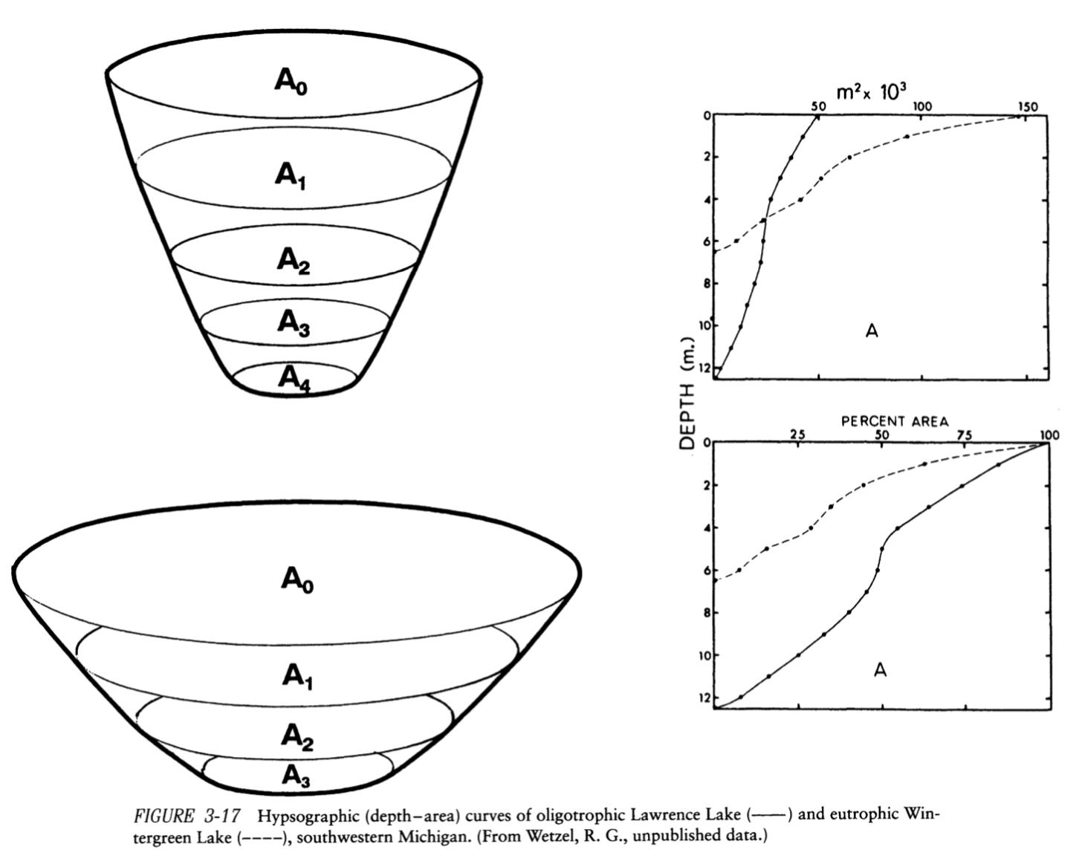
Credit: Limnology: Lake and River Ecosystems, 3rd ed., Wetzel

- (1.5 pts, 0.5 pt each) Indicate whether each of the following is true or false:
  - Lawrence Lake is deeper than Wintergreen Lake.
  - Lawrence Lake is wider than Wintergreen Lake at all depths.
  - Lawrence Lake likely has a much higher phosphate concentration than Wintergreen Lake.

- (0.5 pt) Choose the correct statement. After a long time, under typical lake succession processes, ___ will become more like present-day ___.
  - Lawrence Lake; Wintergreen Lake
  - Wintergreen Lake; Lawrence Lake

- (1 pt) What material will be added or removed from the lake in the first blank in question 2’s statement as the lake transitions? Indicate if the material will be added or removed in your answer.

- (2 pts) A waterproof thermometer at the bottom of an ice-covered lake measures 4°C initially. A prolonged rain and wind event at temperatures slightly above freezing melts all the ice on top of the lake, during which the thermometer records a drop to 3°C.
  - Why does the lake bottom cool when no ice cover is present?
  - What effect does increasing wind speed have on the wave height of the lake? On the rate of cooling of the lake bottom?

- (1 pt) A lake is mostly covered by ice. The ice thaws for about 3 months in the summer but covers the lake for most of the year. Classify the lake.
  - Dimictic
  - Polymictic
  - Amictic
  - Cold monomictic
  - Warm monomictic

- (1 pt) Cayuga Lake (length 38 mi, average width 1.75 mi) is one of the Finger Lakes of New York. In terms of its formation, how is Cayuga Lake similar to kettle lakes? How does the size of Cayuga Lake compare with typical kettle lakes?

For questions 7-10, refer to the following graphs for Anvil Lake, WI. The first two graphs show dissolved oxygen (DO) and water temperature (WT) vs. depth. The next two graphs show pH and specific conductance (SC) vs. depth. The first and third figures are taken from October 2013, and the second and fourth figures are taken from May 2014.

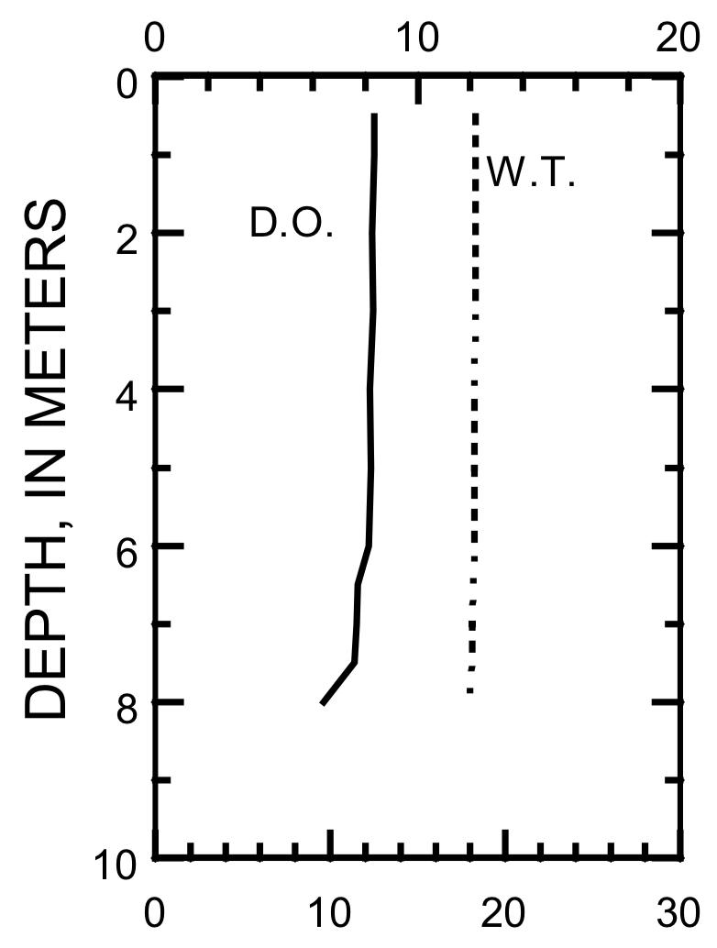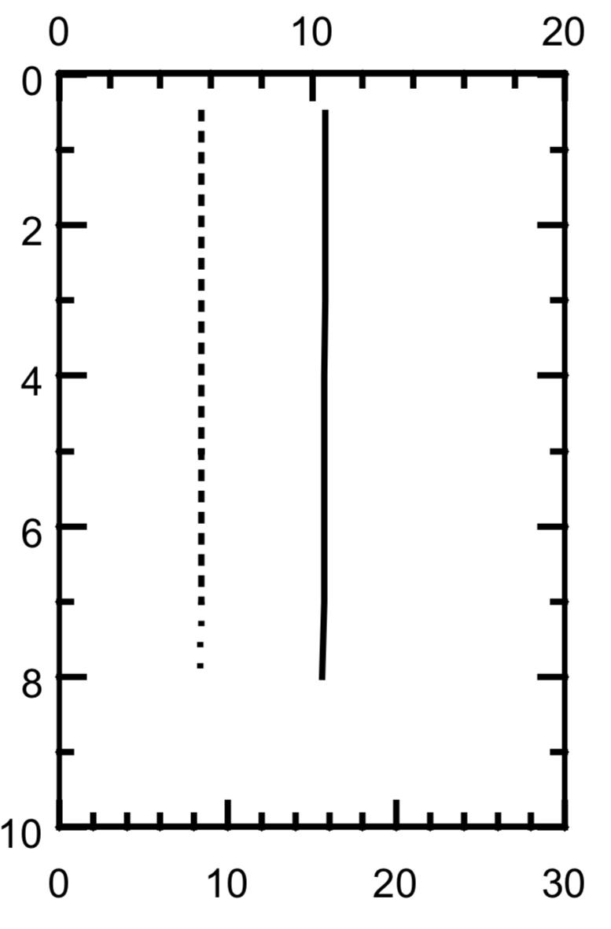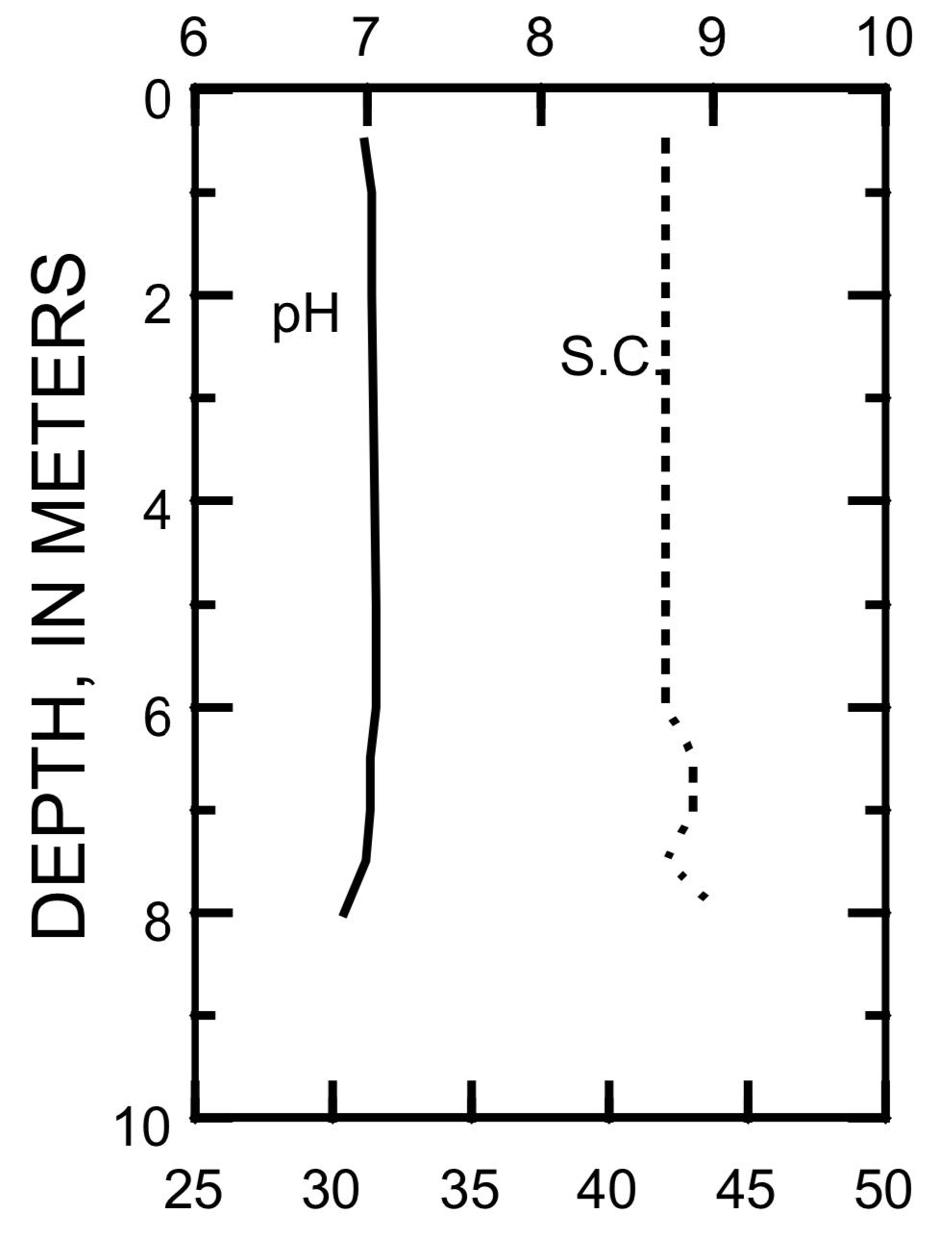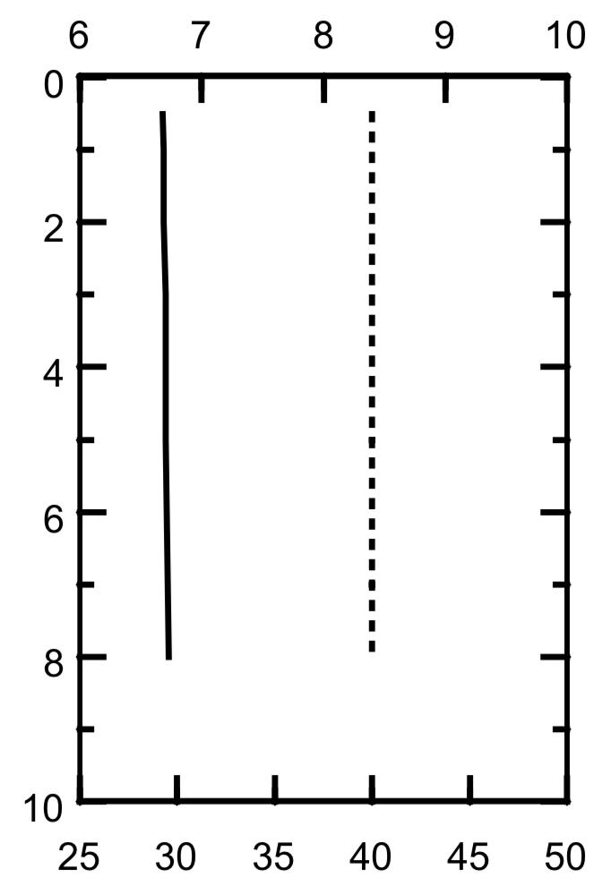
Credit: Water-Quality and Lake-Stage Data for Wisconsin Lakes, Water Year 2014, USGS

- (1 pt) Based on the figures above, if a graph were made of surface DO levels versus temperature, would the slope of the graph be positive, negative, zero, or nearly vertical?

- (2 pts) Assume that the pH content in the lake is strongly dependent on the carbonic acid concentration, and that the lake has negligible plant or bacterial life. Using this, identify and briefly explain the relationship between pH and temperature.

- [TB7] (1.5 pt) Now assume that the pH content in the lake is strongly dependent on the balance between respiration and photosynthesis from plants and bacteria. Why does it make sense that the pH of the lake is lower in May? If this assumption is true, is most of the oxygen supplied to the lake due to photosynthetic sources or atmospheric diffusion?

- (0.5 pt) Was Anvil Lake well mixed or poorly mixed during the dates in which these graphs were taken?

- (1 pt) A scientist wants to use a conductivity meter to determine how polluted a lake is. Persistent organic pollutants (POPs) generally have low solubilities in water.
  - Is a conductivity meter more efficiently able to detect POPs or inorganic pollutants?
  - True or false: POPs can be transported via bed load and suspended load.

- (1 pt) Ephemeral lakes are characterized by
  - Low alkalinity and a generally constant shoreline
  - High alkalinity and a highly variable shoreline
  - Low salinity and a generally constant shoreline
  - High salinity and a highly variable shoreline
  - None of the above

- (1 pt) As you travel in a boat from a high-elevation lake down a river, you pass by some agricultural fields on both sides of the river. You then arrive at a low-elevation lake. Compared to the high-elevation lake, would you expect an increase, decrease, or no change in:
  - Nitrate concentration?
  - Secchi depth, which is proportional to the ability of light to pass through water?

- (1 pt) Suppose you want to go to a lake to see some waves. Assuming the wind speed is the same at each location and blowing from west to east, where would you be most likely to see large waves?
  - At the west end of a lake with a steeply sloping shore
  - At the east end of a lake with a steeply sloping shore
  - At the west end of a lake with a gently sloping shore
  - At the east end of a lake with a gently sloping shore

Section 6: Groundwater is Great [12 pts]
- (1 pt) A region with ___ surface stream concentration and ___ groundwater discharge is the best candidate for karst topography.
  - high; high
  - high; low
  - low; high
  - low; low

- (2 pts) In order to find the hydraulic conductivity k of a rock unit, a student decides to label the x-axis of a graph as the hydraulic gradient. What should the y-axis label be, and how can the graph be used to find k? (Assume that the cross-sectional area is NOT constant)

- [TB1] (2 pts, 0.5 pt each) Refer to Image E (height contours are labeled in ft) and the following data table. Assume the ground material is uniform.

Point | Elevation (ft) | Height above water table (ft)
P | 530 | 30
Q | 500 | 0
R | 550 | 50
S | 600
T | 600

Indicate whether each of the following is true or false:
  - Points P, Q, and R are located on the same water table contour.
  - is likely greater than .
  - If a well at point S pumped a lot of water, the water table contours would probably be concentric (forming circles) around point S.
  - If a drought occurred, the water table contour lines would migrate downstream and would more closely resemble the height contours.

For questions 4-6, refer to Image F, showing a cross-sectional profile of an island. A well is labeled with “W” above it.

- (1 pt) Curves 1, 2, and 3 represent three possible boundaries between freshwater and saltwater, with curve 2 being entirely at sea level. Which curve, under typical conditions, is the most realistic?

- (1 pt) Suppose large amounts of water are pumped up through well W. How will this affect the risk of saltwater intrusion?
  - The risk will increase
  - The risk will decrease
  - The risk will not change

- (1 pt) Justify your answer to the previous question.
  - In the purple region, flow lines which typically point towards the land will increase in magnitude.
  - In the purple region, flow lines which typically point towards the sea will reverse direction.
  - In the purple region, flow lines which typically point towards the sea will increase in magnitude.
  - In the purple region, flow lines which typically point towards the land will reverse direction.
  - The bottom of the well is not in contact with saltwater.

- (1 pt) On the following graph of permeability k versus porosity n, a low-density rock unit with many small, but poorly interconnected pores is best represented by which point?
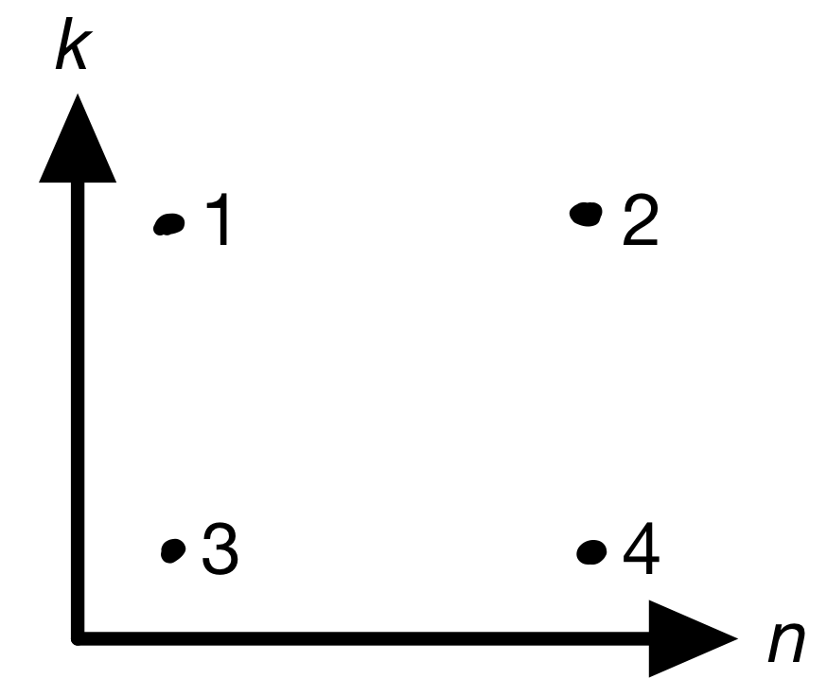
- (1 pt) Capillarity is highest in a sample of:
  - Gravel
  - Sand
  - Silt
  - Clay

- (1 pt) The infiltration rate can be increased by ___ capillarity and ___ the extent of permafrost.
  - Increasing; increasing
  - Increasing; decreasing
  - Decreasing; increasing
  - Decreasing; decreasing

- (1 pt, 0.5 pts each) Aquifers are an important source of groundwater.
  - What is the name given to an aquifer that exists locally above a shallow aquiclude or confining unit, if an unsaturated zone exists below the aquiclude?
  - What feature results at the intersection of such an aquifer or aquiclude, when both are exposed at the surface?

Section 7: Freshwater Finale [12 pts]
- (2 pts) Consider two stream segments, A and B, with the same elevation difference and the same straight-line distance between endpoints, but A has a higher sinuosity. Explain how segment A has a lower average gradient than segment B.

- (2 pts) Which graph below best shows how river sinuosity changes with very long periods of time? For the chosen graph, mention a specific type of lake that forms, and indicate where on the graph this corresponds to.
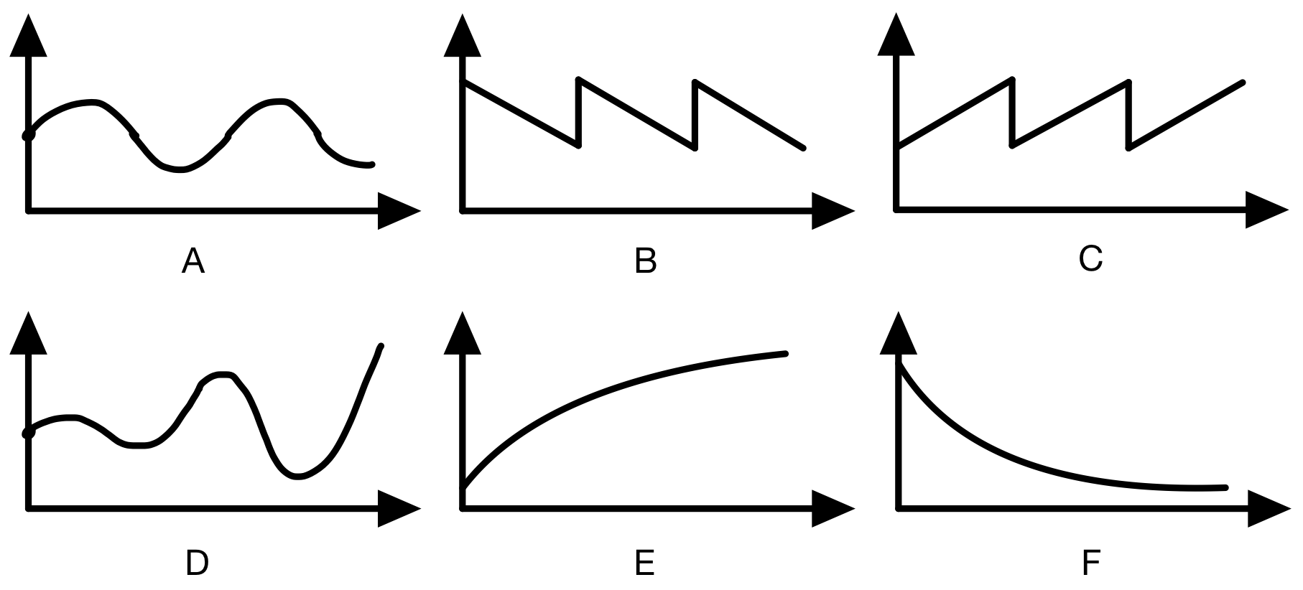

- [TB3] (4 pts) Calculate the discharge of a rectangular stream channel 20 meters wide by 10 meters deep, a Chezy’s coefficient of 60 m^{1/2}/s, and a water surface slope of 0.05 m/m (horizontal distance/vertical distance ratio). Show your calculations. Include the proper units.

- (2 pts, 0.5 pt each) Identify each of the drainage patterns shown.
a.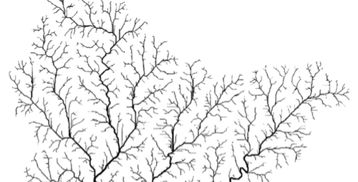b. 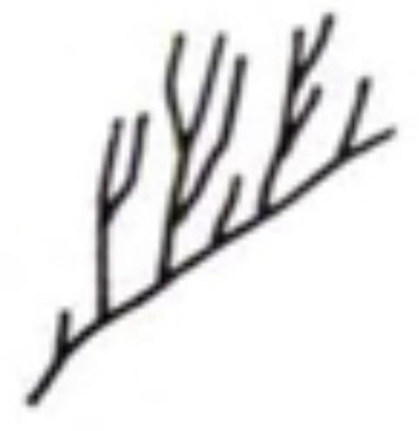c. 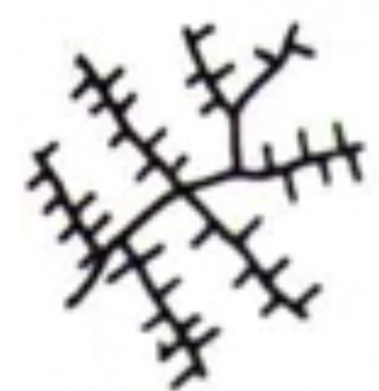
d.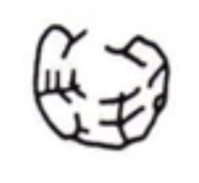

Credit: Rigon et al. 1996, Argialas et al. 1988
- (1 pt) Irrigation canals divert water from the main channel. What is the effect of irrigation canals alone on downstream salinity?
  - They increase downstream salinity
  - They decrease downstream salinity
  - They have no impact on downstream salinity

- (1 pt) Indicate whether each of the following is true or false:
  - Floods can contribute to both erosion and deposition of levees
  - Levees can fail without being directly overtopped

